Determination of Unknown Reactions in a Statically Determinate Beam System
Author: Kathan Patel
Roll No: 23BME067
Course: Engineering Mathematics / Linear Algebra
Tool Used: MATLAB

1. Project Overview
This case study analyzes a statically determinate simply supported beam subjected to external loading.
The objective is to determine the unknown support reactions using:
- Static equilibrium equations
- Matrix formulation
- MATLAB linear algebra solution
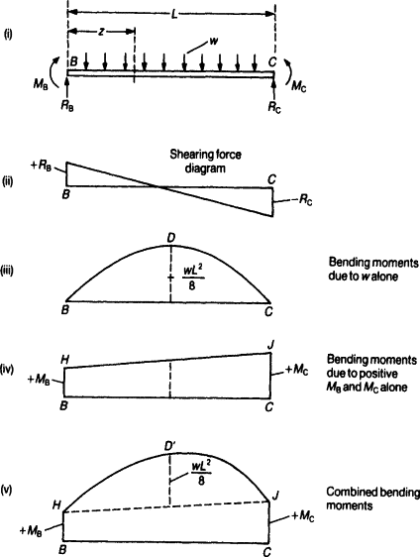
The problem demonstrates how engineering mechanics and linear algebra combine to solve structural systems efficiently.
2. Problem Description
A simply supported beam of length L = 6 m is subjected to a point load of 10 kN located 2 m from the left support (A).
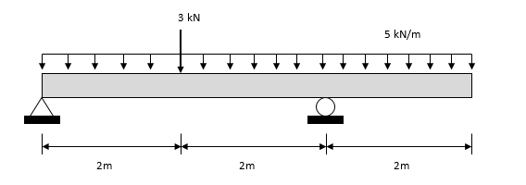

Given:
- Beam length (L) = 6 m
- Point Load (P) = 10 kN
- Distance from A (a) = 2 m
Unknowns:
- $R_{A}$→ Reaction at support A
- $R_{B}$→ Reaction at support B
Since the structure is statically determinate, the number of unknown reactions equals the number of equilibrium equations.

3. Mathematical Formulation
3.1 Equilibrium Conditions
For a 2D beam system:
$$∑F_{y}=0 \\ ∑M_{A}=0$$

3.2 Force Equilibrium
$$R_{A}+R_{B}-P=0 \\ R_{A}+R_{B}=10$$
3.3 Moment Equilibrium (About A)
$$R_{B}⋅L-P⋅a=0 \\ 6R_{B}-10(2)=0 \\ 6R_{B}=20 \\ R_{B}=3.33\text{ kN}$$
Substituting:
$$R_{A}=10-3.33=6.67\text{ kN}$$

4. Matrix Formulation
The equilibrium equations can be written in matrix form:
$$\left[\begin{matrix}1 & 1 \\ 0 & 6\end{matrix}\right]\left[\begin{aligned}R_{A} \\ R_{B}\end{aligned}\right]=\left[\begin{aligned}10 \\ 20\end{aligned}\right]$$
General Linear Algebra Form:
$$\left[A][R]=[B\right]$$
Where:
- $A$→ Coefficient matrix
- $R$→ Reaction vector
- $B$→ Load vector
Solution:
$$[R]=A^{-1}B$$

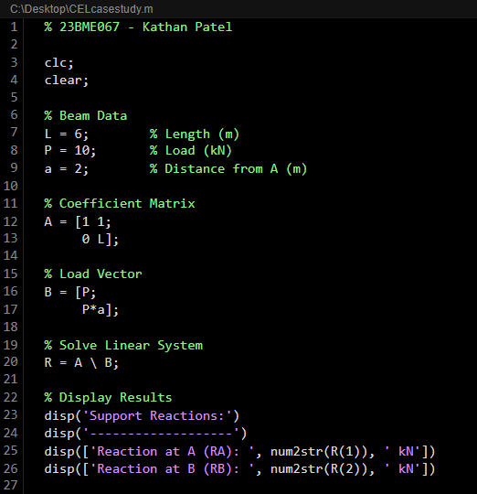
5. MATLAB Implementation

Output:
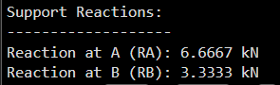

6. Computed Results
Support | Reaction (kN)
A | 6.67
B | 3.33

Verification:
- $R_{A}+R_{B}=10$kN
- Moment equilibrium satisfied

7. Engineering Interpretation
- Left support carries higher load because the point load is closer to A.
- The system satisfies all equilibrium conditions.
- Linear algebra provides a systematic way to solve structural equations.
- This approach can be extended to more complex multi-support systems.

8. Stability Concept
For a statically determinate structure:
- Number of unknown reactions = Number of independent equilibrium equations
- Determinant of coefficient matrix ≠ 0
- Unique solution exists
Since:
$$det(A)=6≠0$$
The system has a unique stable solution.

9. Learning Outcomes
- Application of equilibrium equations
- Conversion of physical system into matrix form
- Solving simultaneous equations using MATLAB
- Understanding of statically determinate structures
- Verification of engineering results
10. Future Enhancements
- Extend to Uniformly Distributed Load (UDL) case
- Compute Shear Force and Bending Moment Diagrams
- Perform symbolic solution using MATLAB
- Analyze statically indeterminate beam
- Convert implementation to Python (NumPy)

11. References
- Hibbeler – Engineering Mechanics (Statics)
- Bansal – Engineering Mechanics
- Gilbert Strang – Linear Algebra and Its Applications
- MATLAB Documentation – Matrix Computations

Conclusion
This case study successfully determines the unknown reactions of a statically determinate beam using equilibrium equations and matrix algebra.
By solving the system:
$$\left[A][R]=[B\right]$$
the support reactions are obtained efficiently using MATLAB.
This demonstrates the powerful application of linear algebra in structural engineering analysis.

